# Exponential population growth

$$N_{t}{=N}_{0}ⅇ^{rt}$$

Where:

N = population size

$N_{0}$ = population size at start

$N_{t}$ = population size at desired time

t = time

e = base of natural logarithm (2,718)

r = rate of increase

r is calculated by: r = b – d

where b is birth rate (births / N )

d is death rate (deaths / N)

r dictates the growth in population. If r>0 population will grow, if r=0 population will stall, if r<0 population will decrease

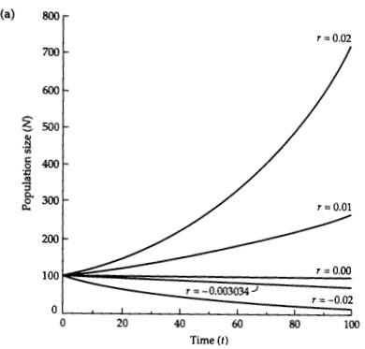

# Logistic population growth

Previous model assumes unlimited recourses and perfect conditions, which does not occur in real life. This model includes recourse depletion and limited space to predict population growth.

$$N_{t}= \frac{K}{1+\left[\frac{\left(K-N_{0}\right)}{N_{0}}\right]e^{-rt}}$$

K – carrying capacity (maximum population size area can support)

Example of the graph where K = 100, $N_{0}=5$

The growth will decrease as population reaches maximum capacity, giving the chart it’s trademark S shape

